|  |  |
| --- | --- |
| **Intelligent Systems** | |
| **Project 2** | |
| **Name** | Student Id |
| **Nilanjan Mhatre** | 801045013 |
| **Akash Raghuvanshi** | 801043608 |

**N-Queens problem (using Hill Climbing search)**

Hill Climbing Algorithm:

Hill Climbing is a heuristic search algorithm used to solve certain optimization problems provided a large set of inputs and an admissible heuristic function, it tries to find a sufficiently good solution to the problem.

Types of Hill climbing

Simple Hill climbing: It examines the neighboring nodes one by one and selects the first neighboring node which optimizes the current cost as the next node.

Steepest-Ascent Hill climbing: It first examines all the neighboring nodes and then selects the node closest to the solution state as the next node.

Stochastic hill climbing: It just selects a neighboring node at random and decides whether to move to that neighbor or to examine another. It does not examine all the neighboring nodes before deciding which node to select.

Challenges faced by hill climbing

Local Maxima: A state which is better than its neighboring state however there exists a state which is better i.e. global maximum.

Random-restart hill climbing overcomes local maxima. It conducts a series of hill-climbing searches from randomly generated initial states until a goal is found.

Plateau/Shoulders: Plateau is where the best successor has the same value as the current state.

Hill climbing with sideways moves escape from plateau hoping that the plateau is really a shoulder, however, can loop on flat maxima so a limit must be applied.

What is N queen problem?

The n-queens problem, originally introduced in 1850 by Carl Gauss, may be stated as follows: find a placement of n queens on an NxN chessboard, such that no one queen can be taken by any other.

The heuristic cost function h is the number of pairs of queens that are attacking each other, either directly or indirectly.

Application of Hill Climbing to solve N queen problem:

* Steepest Hill Climbing: The algorithm halts if it reaches a plateau
* Hill climbing with Side-ways Move: limit of 100 consecutive sideways moves in the 8-queens

problem. This raises the percentage of problem instances solved by hill climbing

from 14% to 94%.

* Random restart search: It conducts a series of hill-climbing searches from randomly generated initial states, until a goal is found.

**Program running instructions**

1. Setup Python environment
   * Install Anaconda
2. Install packages required using “pip” command
   * ***pip install numpy***
   * ***pip install tqdm***
3. Run “N-queens.py”
   * ***python N-queens.py***
   * *## Enter number of queens:*

**Output: -**

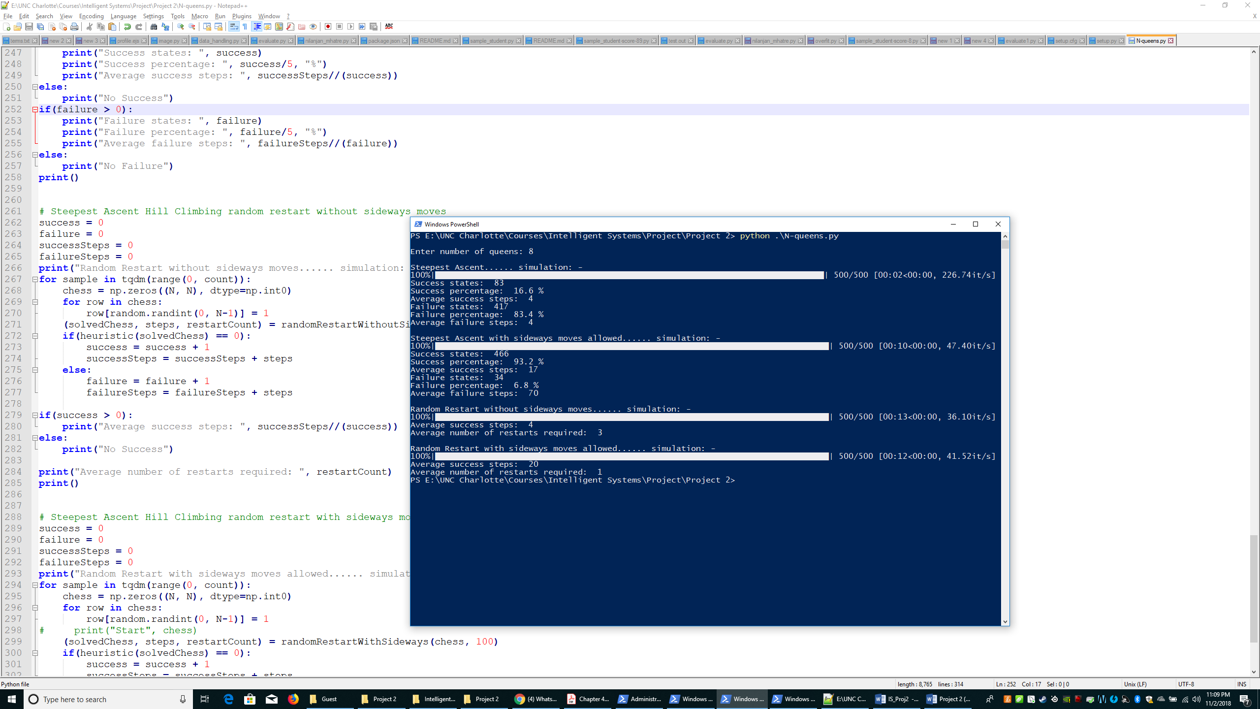

**Program Structure**

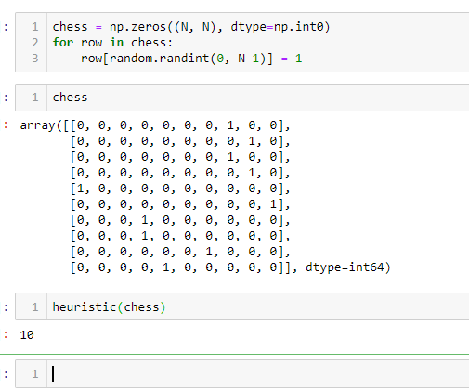

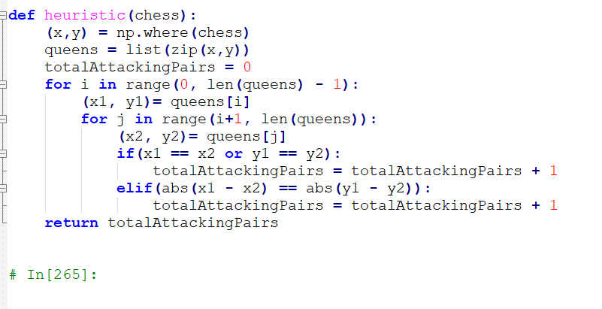

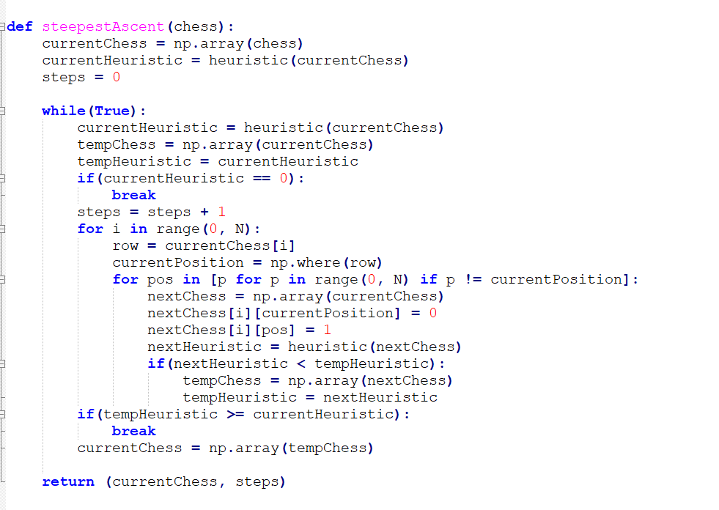

Define Heuristic function = Number of pairs of attacking queens

Steepest Ascent Hill Climbing

* Find the least heuristic child and move to that child
* Continue till a solution is found with heuristic = 0, OR no child has heuristic lower than the parent
* average number of steps when it succeeds: 4
* The average number of steps when it fails: 4

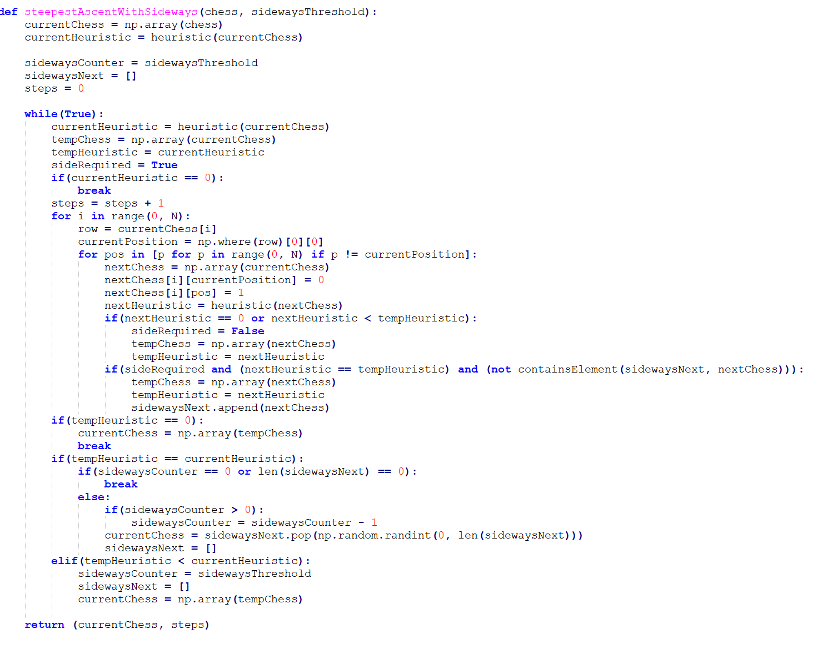

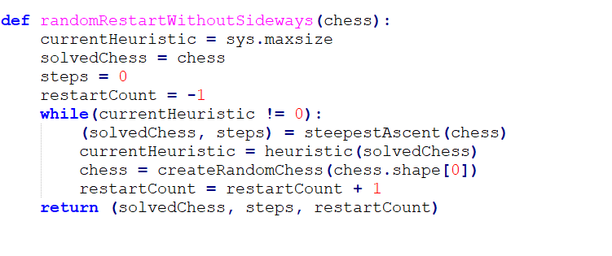

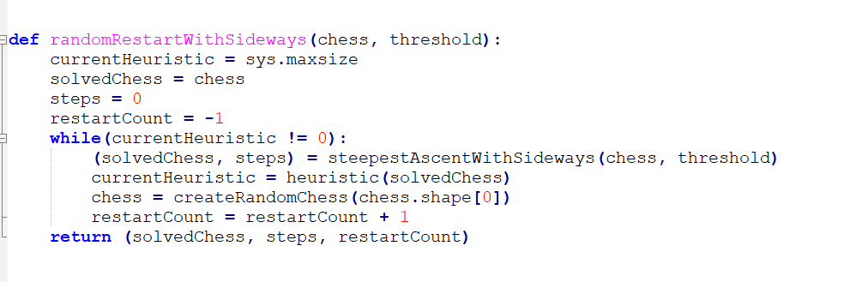

Steepest Ascent Hill Climbing allowing sideways moves: -

* Find the least heuristic child and move to that child
* If the least child/children have the same heuristic as the parent, choose any of the child
* Continue this for a fixed set of iterations
* Reset the iteration counter if a climb is encountered while moving sideways
* average number of steps when it succeeds: 17
* The average number of steps when it fails: 70

Random restart (without sideways): -

* Run the steepest ascent algorithm
* If failed, generate a random initial state, and re-run, until a success state is found
* The average number of random restarts used without sideways move: 7
* The average number of steps required without sideways move:

Random restart (with sideways allowed): -

* Run the steepest ascent algorithm allowing sideways
* It requires fewer restarts of around 1
* If failed, generate a random initial state, and re-run, until a success state is found
* The average number of random restarts used without sideways move: 1
* The average number of steps required without sideways move: 20

**Sample results for Misplaced Tile**

1. Steepest Ascent

Begin

[[0 0 0 1 0 0 0 0]

[0 1 0 0 0 0 0 0]

[0 0 0 0 1 0 0 0]

[0 0 0 0 0 0 1 0]

[0 0 0 0 0 1 0 0]

[0 0 0 0 0 0 0 1]

[0 0 0 0 1 0 0 0]

[0 0 0 1 0 0 0 0]]

Heuristic: 6

[[0 0 0 1 0 0 0 0]

[0 1 0 0 0 0 0 0]

[0 0 0 0 1 0 0 0]

[0 0 1 0 0 0 0 0]

[0 0 0 0 0 1 0 0]

[0 0 0 0 0 0 0 1]

[0 0 0 0 1 0 0 0]

[0 0 0 1 0 0 0 0]]

Heuristic: 4

[[0 0 0 1 0 0 0 0]

[0 1 0 0 0 0 0 0]

[0 0 0 0 0 0 1 0]

[0 0 1 0 0 0 0 0]

[0 0 0 0 0 1 0 0]

[0 0 0 0 0 0 0 1]

[0 0 0 0 1 0 0 0]

[0 0 0 1 0 0 0 0]]

Heuristic: 2

[[0 0 0 1 0 0 0 0]

[0 1 0 0 0 0 0 0]

[0 0 0 0 0 0 1 0]

[0 0 1 0 0 0 0 0]

[0 0 0 0 0 1 0 0]

[0 0 0 0 0 0 0 1]

[0 0 0 0 1 0 0 0]

[1 0 0 0 0 0 0 0]]

Heuristic: 0

Success

Begin

[[0 0 0 0 0 0 0 1]

[0 0 0 0 0 1 0 0]

[0 1 0 0 0 0 0 0]

[0 0 0 0 1 0 0 0]

[1 0 0 0 0 0 0 0]

[0 0 0 0 1 0 0 0]

[0 0 0 0 0 1 0 0]

[0 0 1 0 0 0 0 0]]

Heuristic: 7

[[0 0 0 0 0 0 0 1]

[0 0 0 0 0 1 0 0]

[0 1 0 0 0 0 0 0]

[0 0 0 0 1 0 0 0]

[1 0 0 0 0 0 0 0]

[0 0 0 1 0 0 0 0]

[0 0 0 0 0 1 0 0]

[0 0 1 0 0 0 0 0]]

Heuristic: 3

[[0 0 0 0 0 0 0 1]

[0 0 0 0 0 1 0 0]

[0 1 0 0 0 0 0 0]

[0 0 0 0 1 0 0 0]

[1 0 0 0 0 0 0 0]

[0 0 0 1 0 0 0 0]

[0 0 0 0 0 0 1 0]

[0 0 1 0 0 0 0 0]]

Heuristic: 1

Failure

Begin

[[0 0 0 0 1 0 0 0]

[0 0 0 0 0 1 0 0]

[0 0 0 1 0 0 0 0]

[0 0 0 0 0 0 0 1]

[0 1 0 0 0 0 0 0]

[0 0 0 0 0 0 1 0]

[0 0 0 0 0 0 0 1]

[0 0 0 0 1 0 0 0]]

Heuristic: 11

[[1 0 0 0 0 0 0 0]

[0 0 0 0 0 1 0 0]

[0 0 0 1 0 0 0 0]

[0 0 0 0 0 0 0 1]

[0 1 0 0 0 0 0 0]

[0 0 0 0 0 0 1 0]

[0 0 0 0 0 0 0 1]

[0 0 0 0 1 0 0 0]]

Heuristic: 8

[[1 0 0 0 0 0 0 0]

[0 0 0 0 0 1 0 0]

[0 0 0 1 0 0 0 0]

[0 0 0 0 0 0 0 1]

[0 1 0 0 0 0 0 0]

[0 0 0 0 0 0 1 0]

[0 0 1 0 0 0 0 0]

[0 0 0 0 1 0 0 0]]

Heuristic: 5

[[1 0 0 0 0 0 0 0]

[0 0 0 0 0 1 0 0]

[1 0 0 0 0 0 0 0]

[0 0 0 0 0 0 0 1]

[0 1 0 0 0 0 0 0]

[0 0 0 0 0 0 1 0]

[0 0 1 0 0 0 0 0]

[0 0 0 0 1 0 0 0]]

Heuristic: 4

[[0 0 0 1 0 0 0 0]

[0 0 0 0 0 1 0 0]

[1 0 0 0 0 0 0 0]

[0 0 0 0 0 0 0 1]

[0 1 0 0 0 0 0 0]

[0 0 0 0 0 0 1 0]

[0 0 1 0 0 0 0 0]

[0 0 0 0 1 0 0 0]]

Heuristic: 3

[[0 0 0 1 0 0 0 0]

[0 0 0 0 0 1 0 0]

[1 0 0 0 0 0 0 0]

[0 0 0 0 0 0 0 1]

[0 1 0 0 0 0 0 0]

[0 0 0 0 0 0 1 0]

[0 0 1 0 0 0 0 0]

[1 0 0 0 0 0 0 0]]

Heuristic: 2

Failure

1. Steepest Ascent with sideways

Begin

[[0 1 0 0 0 0 0 0]

[0 0 0 0 1 0 0 0]

[1 0 0 0 0 0 0 0]

[0 0 0 0 0 1 0 0]

[0 0 0 0 1 0 0 0]

[0 1 0 0 0 0 0 0]

[0 0 0 0 0 0 1 0]

[0 1 0 0 0 0 0 0]]

Heuristic: 8

[[0 1 0 0 0 0 0 0]

[0 0 0 0 1 0 0 0]

[1 0 0 0 0 0 0 0]

[0 0 0 0 0 1 0 0]

[0 0 0 1 0 0 0 0]

[0 1 0 0 0 0 0 0]

[0 0 0 0 0 0 1 0]

[0 1 0 0 0 0 0 0]]

Heuristic: 4

[[0 1 0 0 0 0 0 0]

[0 0 0 0 1 0 0 0]

[1 0 0 0 0 0 0 0]

[0 0 0 0 0 1 0 0]

[0 0 0 1 0 0 0 0]

[0 1 0 0 0 0 0 0]

[0 0 0 0 0 0 1 0]

[0 0 1 0 0 0 0 0]]

Heuristic: 1

[[0 0 0 0 1 0 0 0]

[0 0 0 0 1 0 0 0]

[1 0 0 0 0 0 0 0]

[0 0 0 0 0 1 0 0]

[0 0 0 1 0 0 0 0]

[0 1 0 0 0 0 0 0]

[0 0 0 0 0 0 1 0]

[0 0 1 0 0 0 0 0]]

Heuristic: 1

[[0 1 0 0 0 0 0 0]

[0 0 0 0 1 0 0 0]

[1 0 0 0 0 0 0 0]

[0 0 0 0 0 1 0 0]

[0 0 0 1 0 0 0 0]

[0 1 0 0 0 0 0 0]

[0 0 0 0 0 0 1 0]

[0 0 1 0 0 0 0 0]]

Heuristic: 1

[[0 0 0 0 1 0 0 0]

[0 0 0 0 1 0 0 0]

[1 0 0 0 0 0 0 0]

[0 0 0 0 0 1 0 0]

[0 0 0 1 0 0 0 0]

[0 1 0 0 0 0 0 0]

[0 0 0 0 0 0 1 0]

[0 0 1 0 0 0 0 0]]

Heuristic: 1

[[0 1 0 0 0 0 0 0]

[0 0 0 0 1 0 0 0]

[1 0 0 0 0 0 0 0]

[0 0 0 0 0 1 0 0]

[0 0 0 1 0 0 0 0]

[0 1 0 0 0 0 0 0]

[0 0 0 0 0 0 1 0]

[0 0 1 0 0 0 0 0]]

Heuristic: 1

[[0 0 0 0 0 0 0 1]

[0 0 0 0 1 0 0 0]

[1 0 0 0 0 0 0 0]

[0 0 0 0 0 1 0 0]

[0 0 0 1 0 0 0 0]

[0 1 0 0 0 0 0 0]

[0 0 0 0 0 0 1 0]

[0 0 1 0 0 0 0 0]]

Heuristic: 1

[[0 1 0 0 0 0 0 0]

[0 0 0 0 1 0 0 0]

[1 0 0 0 0 0 0 0]

[0 0 0 0 0 1 0 0]

[0 0 0 1 0 0 0 0]

[0 1 0 0 0 0 0 0]

[0 0 0 0 0 0 1 0]

[0 0 1 0 0 0 0 0]]

Heuristic: 1

[[0 1 0 0 0 0 0 0]

[0 0 0 0 1 0 0 0]

[1 0 0 0 0 0 0 0]

[0 0 0 0 0 0 0 1]

[0 0 0 1 0 0 0 0]

[0 1 0 0 0 0 0 0]

[0 0 0 0 0 0 1 0]

[0 0 1 0 0 0 0 0]]

Failure

Begin

[[0 0 1 0 0 0 0 0]

[0 0 0 0 1 0 0 0]

[0 1 0 0 0 0 0 0]

[0 0 0 0 1 0 0 0]

[1 0 0 0 0 0 0 0]

[0 0 0 0 0 0 1 0]

[0 0 0 0 0 0 1 0]

[1 0 0 0 0 0 0 0]]

Heuristic: 5

[[0 0 1 0 0 0 0 0]

[0 0 0 0 1 0 0 0]

[0 1 0 0 0 0 0 0]

[0 0 0 0 0 0 0 1]

[1 0 0 0 0 0 0 0]

[0 0 0 0 0 0 1 0]

[0 0 0 0 0 0 1 0]

[1 0 0 0 0 0 0 0]]

Heuristic: 2

[[0 0 1 0 0 0 0 0]

[0 0 0 0 1 0 0 0]

[0 1 0 0 0 0 0 0]

[0 0 0 0 0 0 0 1]

[1 0 0 0 0 0 0 0]

[0 0 0 1 0 0 0 0]

[0 0 0 0 0 0 1 0]

[1 0 0 0 0 0 0 0]]

Heuristic: 1

[[0 0 1 0 0 0 0 0]

[0 0 0 0 1 0 0 0]

[0 1 0 0 0 0 0 0]

[0 0 0 0 0 0 0 1]

[0 0 0 0 0 1 0 0]

[0 0 0 1 0 0 0 0]

[0 0 0 0 0 0 1 0]

[1 0 0 0 0 0 0 0]]

Heuristic: 0

Success

Begin

[[0 0 0 1 0 0 0 0]

[0 1 0 0 0 0 0 0]

[0 0 0 0 1 0 0 0]

[0 0 0 0 0 0 1 0]

[0 0 0 0 0 1 0 0]

[0 0 0 0 0 0 0 1]

[0 0 0 0 1 0 0 0]

[0 0 0 1 0 0 0 0]]

Heuristic: 6

[[0 0 0 1 0 0 0 0]

[0 1 0 0 0 0 0 0]

[0 0 0 0 1 0 0 0]

[0 0 1 0 0 0 0 0]

[0 0 0 0 0 1 0 0]

[0 0 0 0 0 0 0 1]

[0 0 0 0 1 0 0 0]

[0 0 0 1 0 0 0 0]]

Heuristic: 4

[[0 0 0 1 0 0 0 0]

[0 1 0 0 0 0 0 0]

[0 0 0 0 0 0 1 0]

[0 0 1 0 0 0 0 0]

[0 0 0 0 0 1 0 0]

[0 0 0 0 0 0 0 1]

[0 0 0 0 1 0 0 0]

[0 0 0 1 0 0 0 0]]

Heuristic: 2

[[0 0 0 1 0 0 0 0]

[0 1 0 0 0 0 0 0]

[0 0 0 0 0 0 1 0]

[0 0 1 0 0 0 0 0]

[0 0 0 0 0 1 0 0]

[0 0 0 0 0 0 0 1]

[0 0 0 0 1 0 0 0]

[1 0 0 0 0 0 0 0]]

Heuristic: 0

Success

1. Random restart without sideways

Begin

[[1 0 0 0 0 0 0 0]

[0 0 0 0 1 0 0 0]

[0 1 0 0 0 0 0 0]

[0 0 0 0 0 0 0 1]

[0 0 0 0 1 0 0 0]

[0 1 0 0 0 0 0 0]

[0 0 0 0 1 0 0 0]

[0 0 0 0 0 0 0 1]]

Heuristic: 9

[[1 0 0 0 0 0 0 0]

[0 0 0 0 1 0 0 0]

[0 1 0 0 0 0 0 0]

[0 0 0 0 0 0 0 1]

[0 0 0 0 0 1 0 0]

[0 1 0 0 0 0 0 0]

[0 0 0 0 1 0 0 0]

[0 0 0 0 0 0 0 1]]

Heuristic: 5

[[0 0 1 0 0 0 0 0]

[0 0 0 0 1 0 0 0]

[0 1 0 0 0 0 0 0]

[0 0 0 0 0 0 0 1]

[0 0 0 0 0 1 0 0]

[0 1 0 0 0 0 0 0]

[0 0 0 0 1 0 0 0]

[0 0 0 0 0 0 0 1]]

Heuristic: 4

[[0 0 1 0 0 0 0 0]

[0 0 0 0 0 0 1 0]

[0 1 0 0 0 0 0 0]

[0 0 0 0 0 0 0 1]

[0 0 0 0 0 1 0 0]

[0 1 0 0 0 0 0 0]

[0 0 0 0 1 0 0 0]

[0 0 0 0 0 0 0 1]]

Heuristic: 3

[[0 0 1 0 0 0 0 0]

[0 0 0 0 0 0 1 0]

[0 1 0 0 0 0 0 0]

[1 0 0 0 0 0 0 0]

[0 0 0 0 0 1 0 0]

[0 1 0 0 0 0 0 0]

[0 0 0 0 1 0 0 0]

[0 0 0 0 0 0 0 1]]

Heuristic: 2

[[0 0 1 0 0 0 0 0]

[0 0 0 0 0 0 1 0]

[0 0 0 1 0 0 0 0]

[1 0 0 0 0 0 0 0]

[0 0 0 0 0 1 0 0]

[0 1 0 0 0 0 0 0]

[0 0 0 0 1 0 0 0]

[0 0 0 0 0 0 0 1]]

Heuristic: 1

Failure

Begin

[[0 1 0 0 0 0 0 0]

[0 0 0 0 1 0 0 0]

[0 1 0 0 0 0 0 0]

[1 0 0 0 0 0 0 0]

[0 0 0 0 1 0 0 0]

[0 0 0 0 0 0 1 0]

[0 0 0 0 0 1 0 0]

[0 0 0 1 0 0 0 0]]

Heuristic: 6

[[0 1 0 0 0 0 0 0]

[0 0 0 0 1 0 0 0]

[0 0 0 0 0 0 0 1]

[1 0 0 0 0 0 0 0]

[0 0 0 0 1 0 0 0]

[0 0 0 0 0 0 1 0]

[0 0 0 0 0 1 0 0]

[0 0 0 1 0 0 0 0]]

Heuristic: 3

[[0 0 1 0 0 0 0 0]

[0 0 0 0 1 0 0 0]

[0 0 0 0 0 0 0 1]

[1 0 0 0 0 0 0 0]

[0 0 0 0 1 0 0 0]

[0 0 0 0 0 0 1 0]

[0 0 0 0 0 1 0 0]

[0 0 0 1 0 0 0 0]]

Heuristic: 2

[[0 0 1 0 0 0 0 0]

[0 0 0 0 1 0 0 0]

[0 0 0 0 0 0 0 1]

[1 0 0 0 0 0 0 0]

[0 0 0 0 1 0 0 0]

[0 0 0 0 0 0 1 0]

[0 1 0 0 0 0 0 0]

[0 0 0 1 0 0 0 0]]

Heuristic: 1

[[0 0 1 0 0 0 0 0]

[0 0 0 0 0 1 0 0]

[0 0 0 0 0 0 0 1]

[1 0 0 0 0 0 0 0]

[0 0 0 0 1 0 0 0]

[0 0 0 0 0 0 1 0]

[0 1 0 0 0 0 0 0]

[0 0 0 1 0 0 0 0]]

Heuristic: 0

Success

1. Random restart with sideways allowed

Begin

[[0 0 0 1 0 0 0 0]

[0 0 1 0 0 0 0 0]

[0 0 1 0 0 0 0 0]

[0 0 0 0 0 0 1 0]

[0 0 1 0 0 0 0 0]

[0 0 0 0 0 0 0 1]

[0 0 0 0 0 1 0 0]

[0 0 1 0 0 0 0 0]]

Heuristic: 9

[[0 0 0 1 0 0 0 0]

[0 0 1 0 0 0 0 0]

[0 0 1 0 0 0 0 0]

[0 0 0 0 0 0 1 0]

[0 0 1 0 0 0 0 0]

[0 0 0 0 0 0 0 1]

[0 0 0 0 0 1 0 0]

[1 0 0 0 0 0 0 0]]

Heuristic: 5

[[0 0 0 1 0 0 0 0]

[0 1 0 0 0 0 0 0]

[0 0 1 0 0 0 0 0]

[0 0 0 0 0 0 1 0]

[0 0 1 0 0 0 0 0]

[0 0 0 0 0 0 0 1]

[0 0 0 0 0 1 0 0]

[1 0 0 0 0 0 0 0]]

Heuristic: 3

[[0 0 0 1 0 0 0 0]

[0 1 0 0 0 0 0 0]

[0 0 0 1 0 0 0 0]

[0 0 0 0 0 0 1 0]

[0 0 1 0 0 0 0 0]

[0 0 0 0 0 0 0 1]

[0 0 0 0 0 1 0 0]

[1 0 0 0 0 0 0 0]]

Heuristic: 2

Begin

[[0 0 0 0 1 0 0 0]

[0 0 0 0 0 0 0 1]

[0 0 0 0 0 0 1 0]

[0 0 0 0 1 0 0 0]

[0 0 0 1 0 0 0 0]

[0 0 0 1 0 0 0 0]

[0 0 0 0 1 0 0 0]

[0 0 0 0 0 1 0 0]]

Heuristic: 12

[[0 0 0 0 1 0 0 0]

[0 0 0 0 0 0 0 1]

[0 0 0 0 0 0 1 0]

[0 0 0 0 1 0 0 0]

[0 0 0 1 0 0 0 0]

[1 0 0 0 0 0 0 0]

[0 0 0 0 1 0 0 0]

[0 0 0 0 0 1 0 0]]

Heuristic: 7

[[0 0 1 0 0 0 0 0]

[0 0 0 0 0 0 0 1]

[0 0 0 0 0 0 1 0]

[0 0 0 0 1 0 0 0]

[0 0 0 1 0 0 0 0]

[1 0 0 0 0 0 0 0]

[0 0 0 0 1 0 0 0]

[0 0 0 0 0 1 0 0]]

Heuristic: 4

[[0 0 1 0 0 0 0 0]

[0 0 0 0 0 0 0 1]

[0 0 0 0 0 0 1 0]

[1 0 0 0 0 0 0 0]

[0 0 0 1 0 0 0 0]

[1 0 0 0 0 0 0 0]

[0 0 0 0 1 0 0 0]

[0 0 0 0 0 1 0 0]]

Heuristic: 3

[[0 0 1 0 0 0 0 0]

[0 0 0 0 0 0 0 1]

[0 0 0 0 0 0 1 0]

[1 0 0 0 0 0 0 0]

[0 0 0 1 0 0 0 0]

[0 1 0 0 0 0 0 0]

[0 0 0 0 1 0 0 0]

[0 0 0 0 0 1 0 0]]

Heuristic: 2

[[0 0 1 0 0 0 0 0]

[0 0 0 0 1 0 0 0]

[0 0 0 0 0 0 1 0]

[1 0 0 0 0 0 0 0]

[0 0 0 1 0 0 0 0]

[0 1 0 0 0 0 0 0]

[0 0 0 0 1 0 0 0]

[0 0 0 0 0 1 0 0]]

Heuristic: 2

[[0 0 1 0 0 0 0 0]

[0 0 0 0 1 0 0 0]

[0 0 0 0 0 0 0 1]

[1 0 0 0 0 0 0 0]

[0 0 0 0 1 0 0 0]

[0 0 0 0 0 0 1 0]

[0 1 0 0 0 0 0 0]

[0 0 0 1 0 0 0 0]]

Heuristic: 1

[[0 0 1 0 0 0 0 0]

[0 0 0 0 0 1 0 0]

[0 0 0 0 0 0 0 1]

[1 0 0 0 0 0 0 0]

[0 0 0 0 1 0 0 0]

[0 0 0 0 0 0 1 0]

[0 1 0 0 0 0 0 0]

[0 0 0 1 0 0 0 0]]

Heuristic: 0

success